New Faculty and DMAI
(in one.iu.edu)

DMAI has three main roles:
- Providing information for annual reviews
- Preparing a CV in the approved IUPUI format for promotion and tenure processes
- Providing schools or departments with ways of generating lists of accomplishments, e.g. allpublications in the last five years by school faculty.
If you used DMAI at your previous institution, let acadhr@iupui.edu know. We can import your datafrom that institution to this.

Data gets into DMAI in four ways:
- Auto-populated: This includes
  - IU system courses, back to 2012 and loaded every year.
  - IU appointments, from first appointment
  - Grants and contracts administered by IU
- Batch automated loading: For publications recorded in Google Scholar,
PubMed, and someother sources
  - Manage Activities (top menubar), Research/Creative Activity (menu choice),
Publications/Scholarship of Discovery
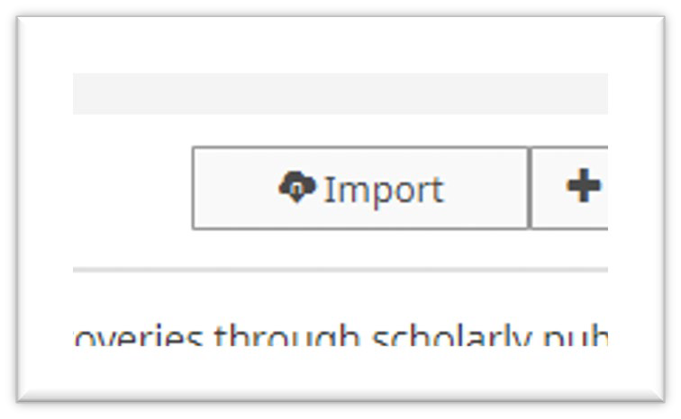
  - Import

Do not assume that PubMed is the best choice.
For help, contact your school’s liaison librarian or the University Library’s Center forDigital Scholarship. Tip: set up a Google Scholar profile and an ORCID if you do not already have them.

Librarians can assist with that.
- For each citation imported, you will ALSO have to indicate what area it pertains to:
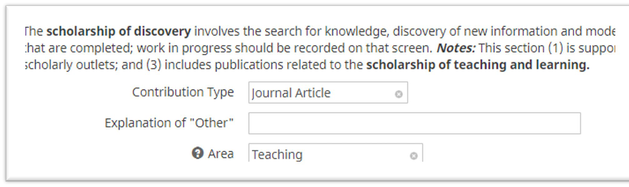
- Batch manual loading: This means you sit down with your CV and enter everything intoDMAI. The most important categories are:
  - Presentations
  - Book chapters not already imported
  - Any professional development you attend
  - Any professional development you teach
  - There is a new “CV Imports” feature.
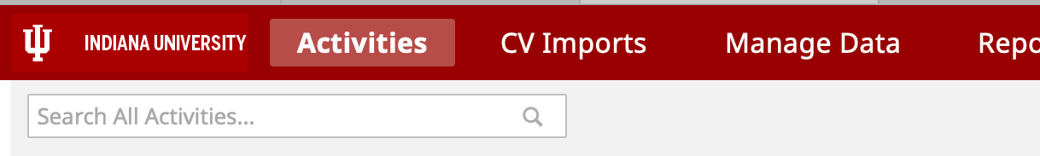

This does not ‘import’ your CV as a whole. What it does upload your CV then you identify (byhighlighting) each item to be added to the DMAI record—it will walk you through each field.
One by one by one
If you type fast, you’ll do better on your own
The only thing that makes it faster than adding by hand is that you do not need to type in articleor journal titles—you just highlight what they are.

Once you have everything in, run reports: Rapid Reports
Select, Vita – IUPUI CV Format

Make sure you adjust the beginning year
Missing items are usually missing because you did not indicate an ‘area.’

Rapid Reports
Select, Annual Reports
This will be due by the end of January for your chair.
IU does ‘annual’ reports on a calendar year basis. Each January you report on the previouscalendar year. Yes, your first report will be short!

